Assignment #HW6 Developmental Systems

CSSE490: Bio-Inspired Artificial Intelligence

Prepared and submitted by:

Lyra Lee

Collaboration and resources:

I worked alone

Resources I used to complete this assignment (websites, textbook, friends, etc.):

Stack overflow

Nature of Code

Python documentation

Checkpoint #1:

Provide a screenshot of your code outputting the generated words.

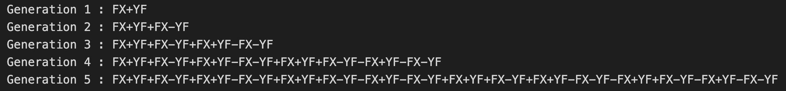

_______________________________________________________________

Checkpoint #2:

2.a Provide a screenshot of your graph of the “dragon curve”

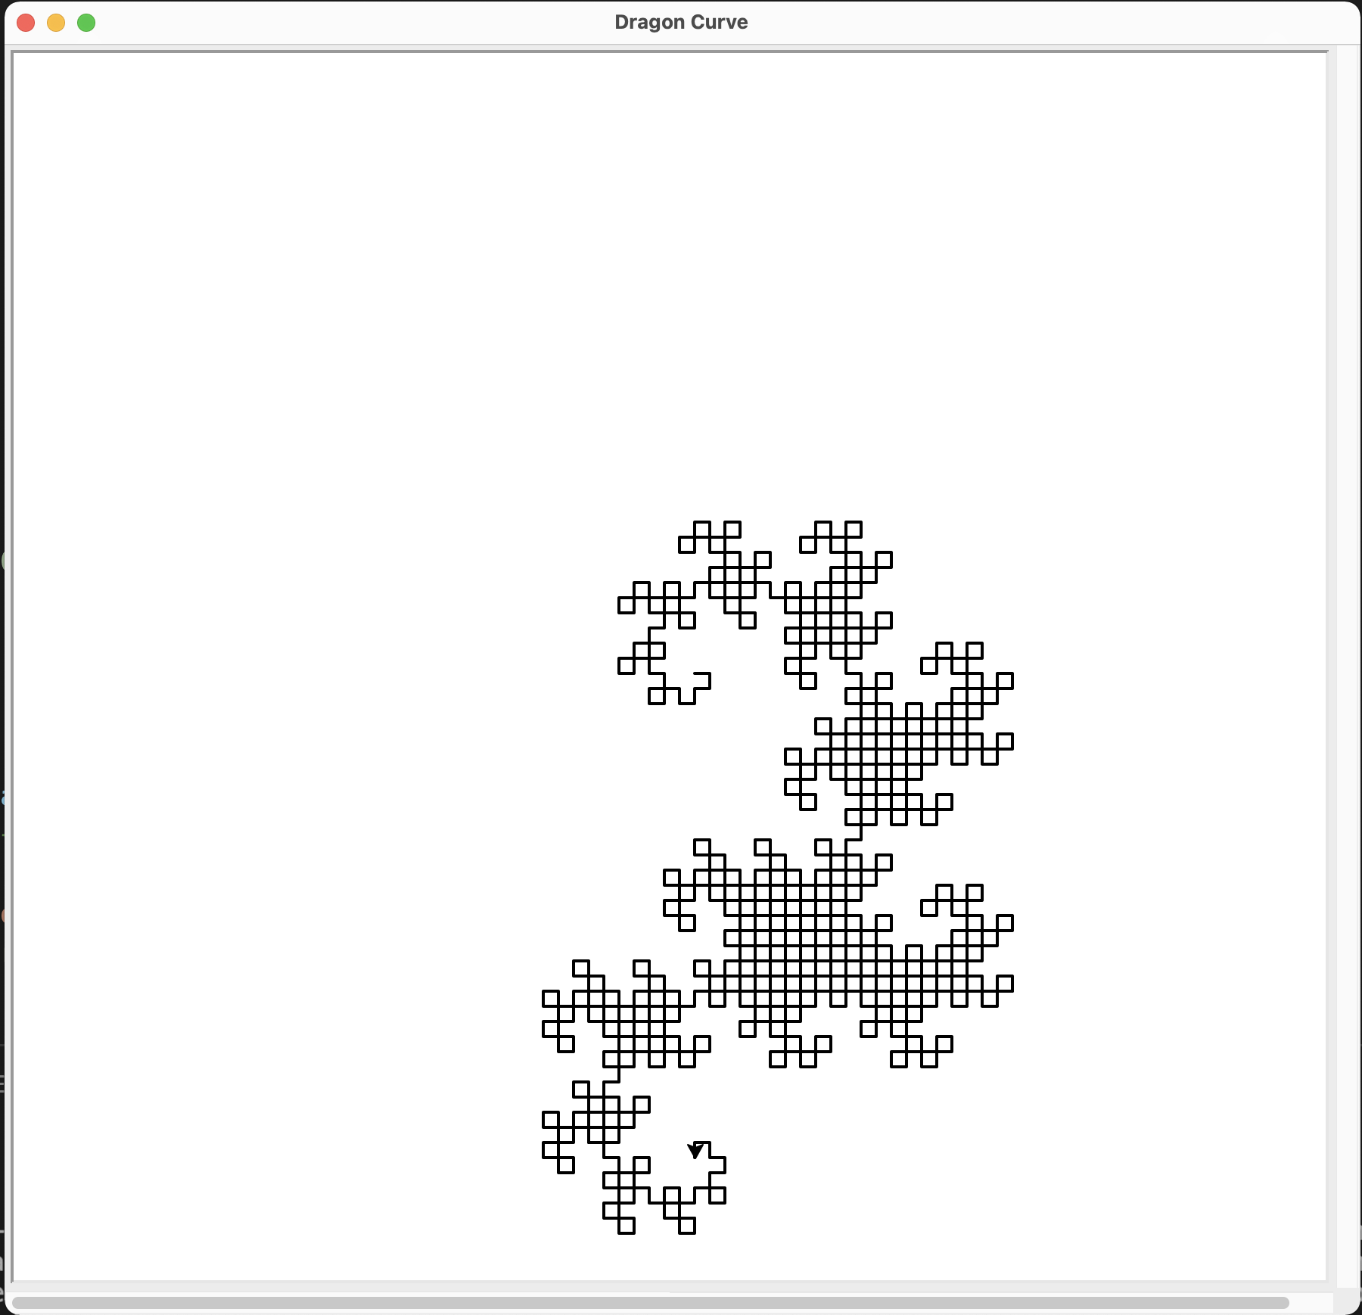

2.b Provide a screenshot of your choice of another non-branching L-System

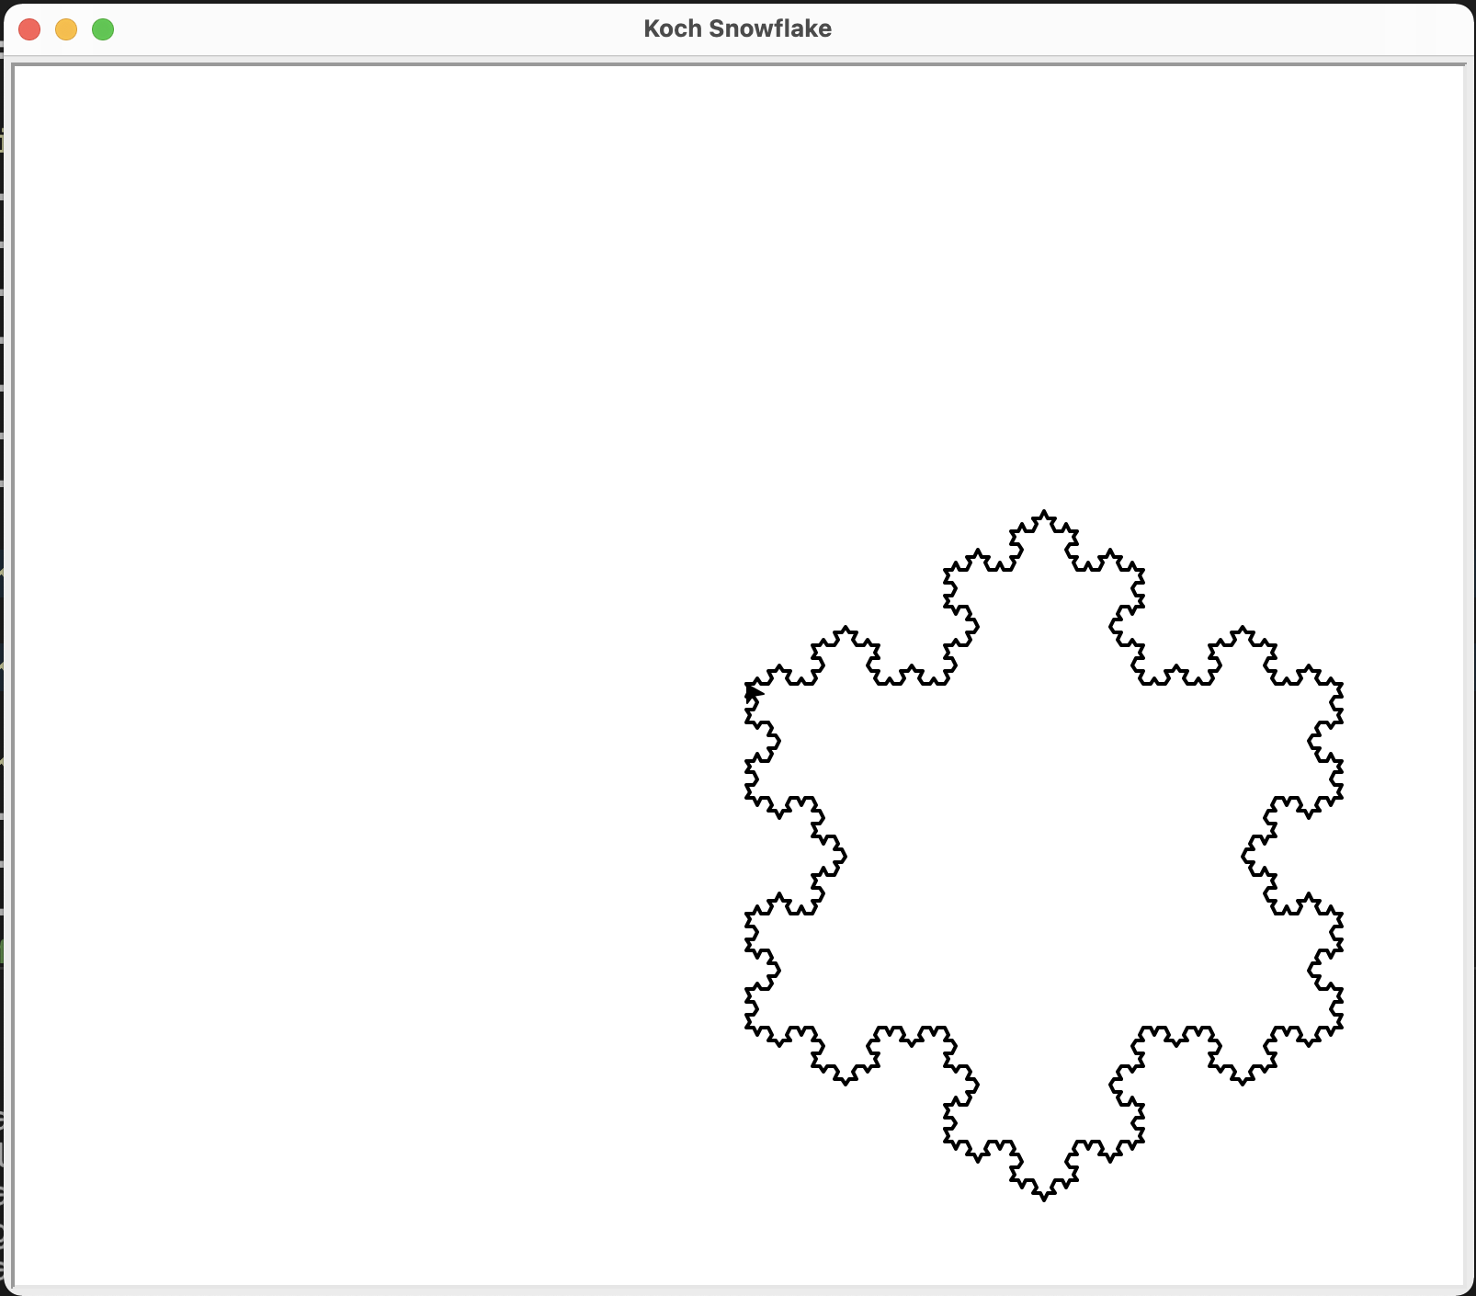

_______________________________________________________________

Checkpoint #3:

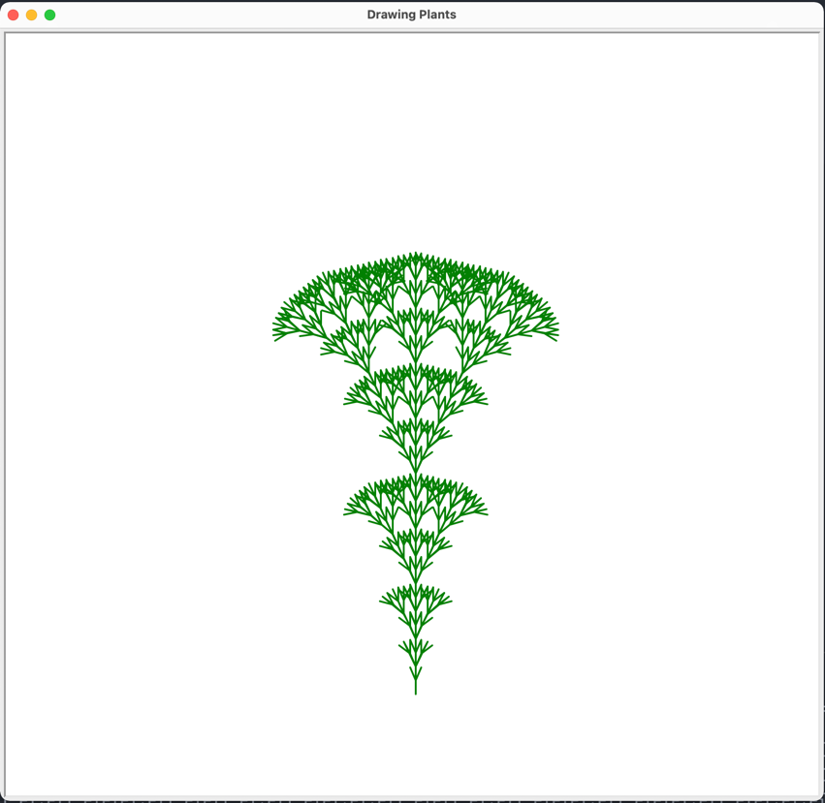3.a L-System 1

3.b L-System 2

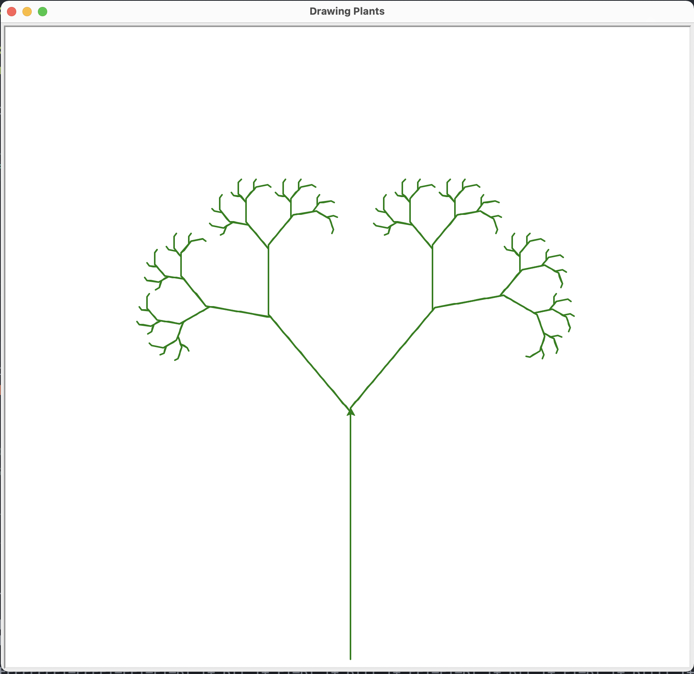

_______________________________________________________________

Checkpoint #4:

Provide a screenshot for your L-System tree forest containing at least 3 different trees:

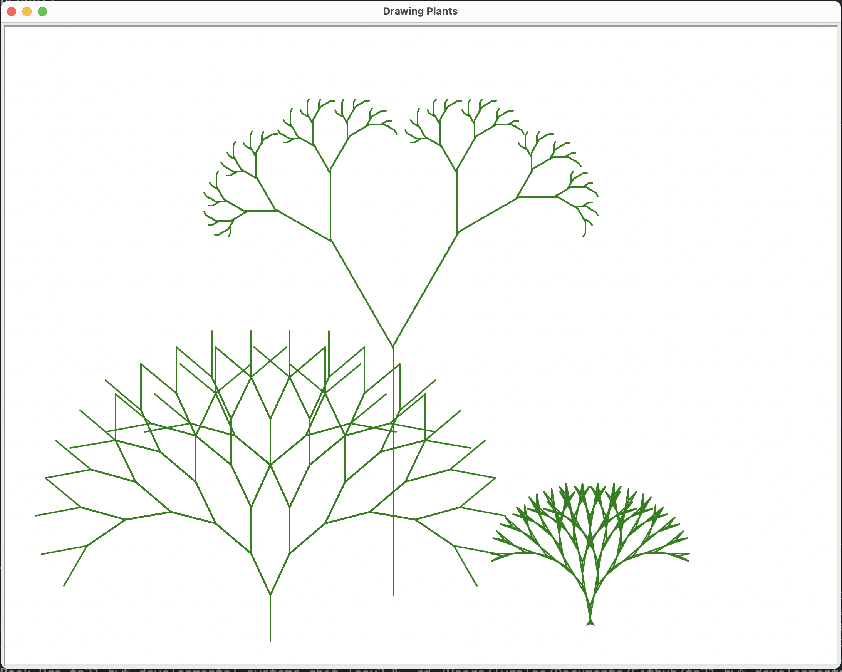

_______________________________________________________________

Awesomesauce:

Include any work you did including the Optional or other explorations you would like to consider for awesomesauce.

